Created Jenkins Master and slave installed Git, Maven, tomcat, Java and Jenkins in JM and Java and tomcat git and maven on Slave machine

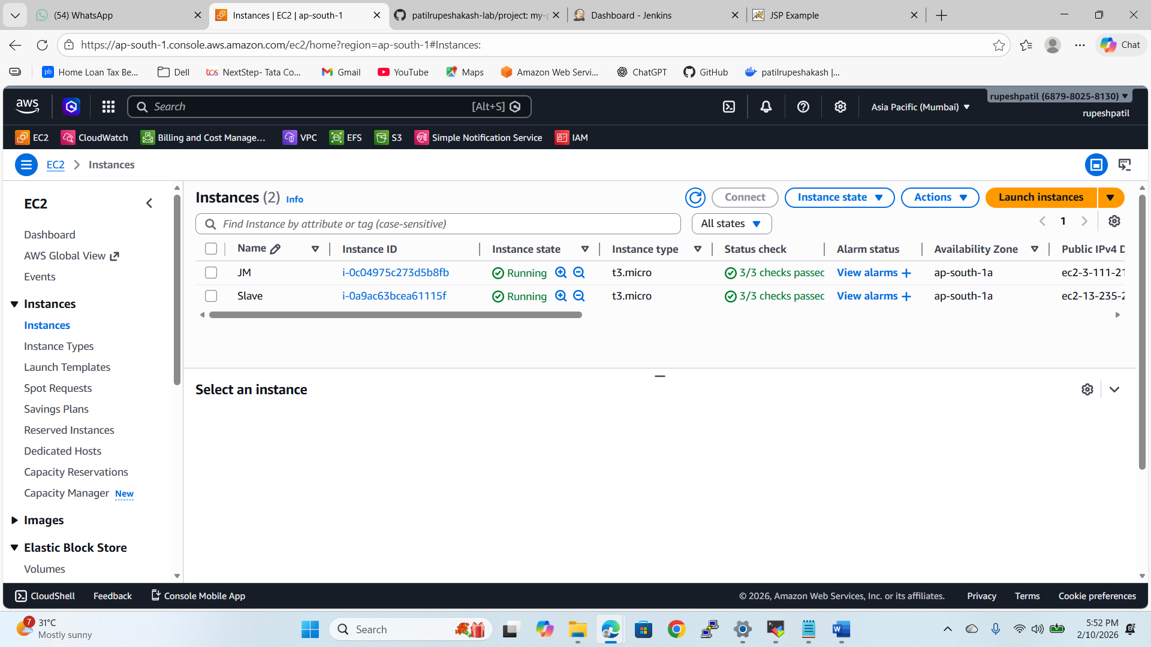

Created the job and Restrict where this project can be run. On slave machine 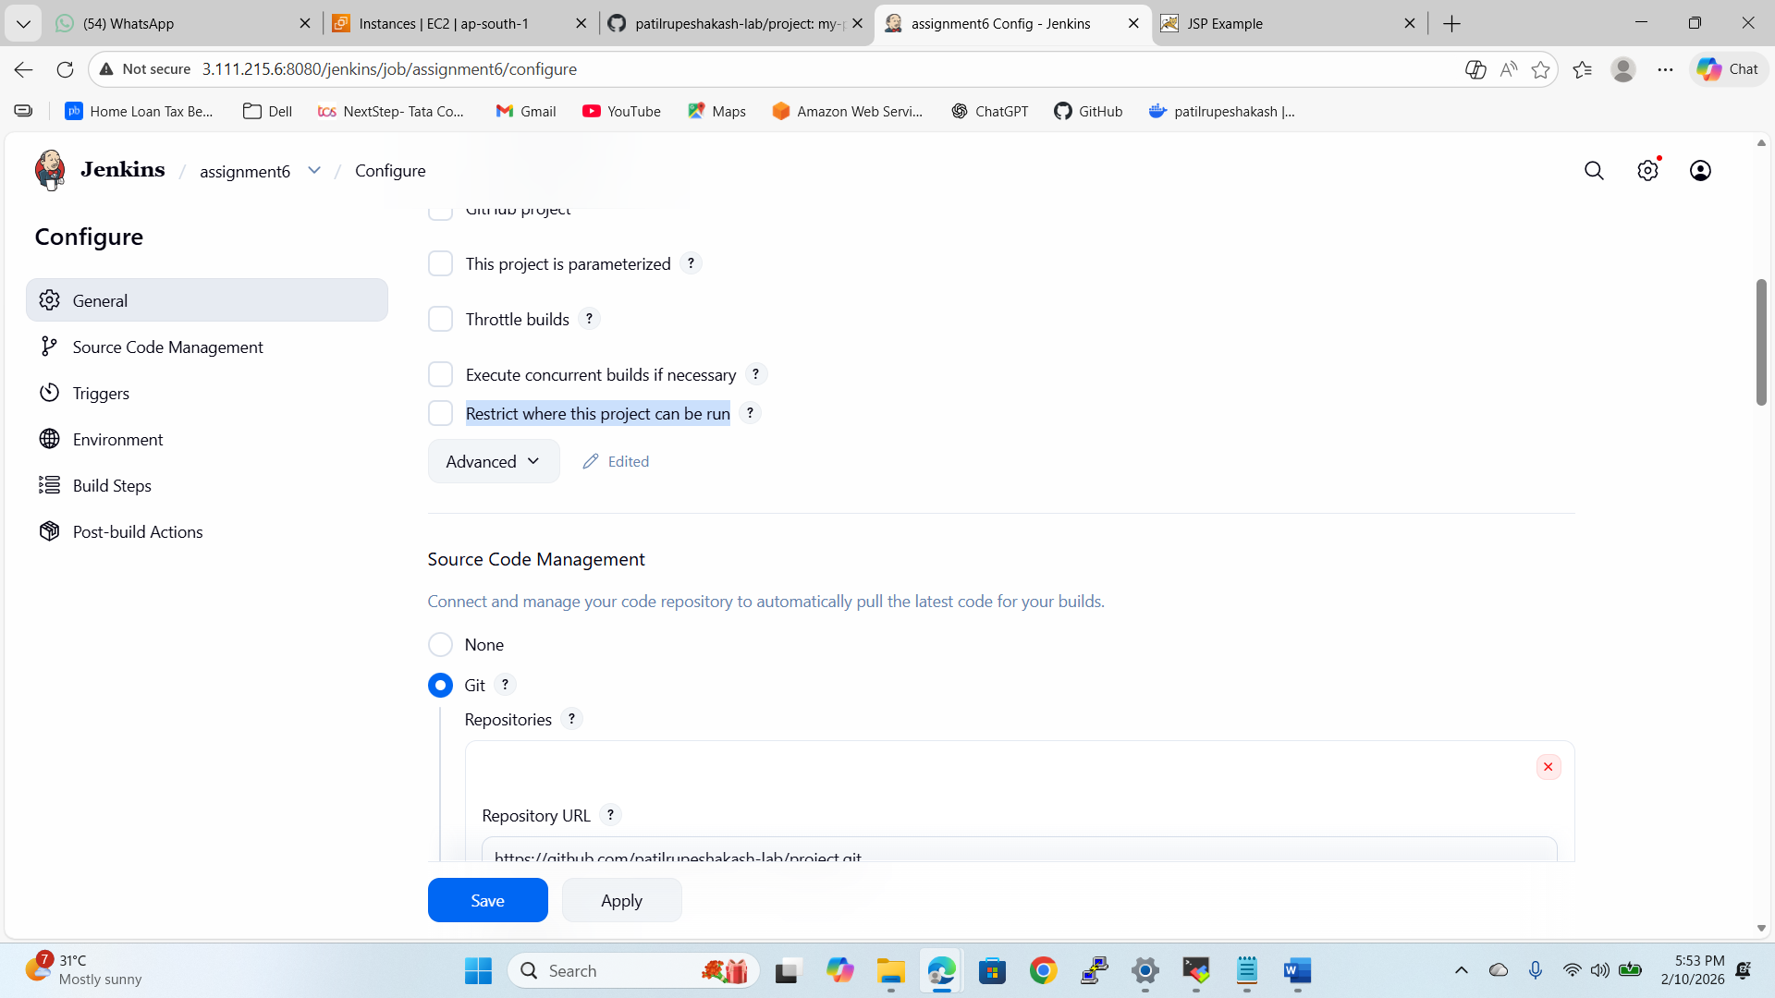
Added GIT repo 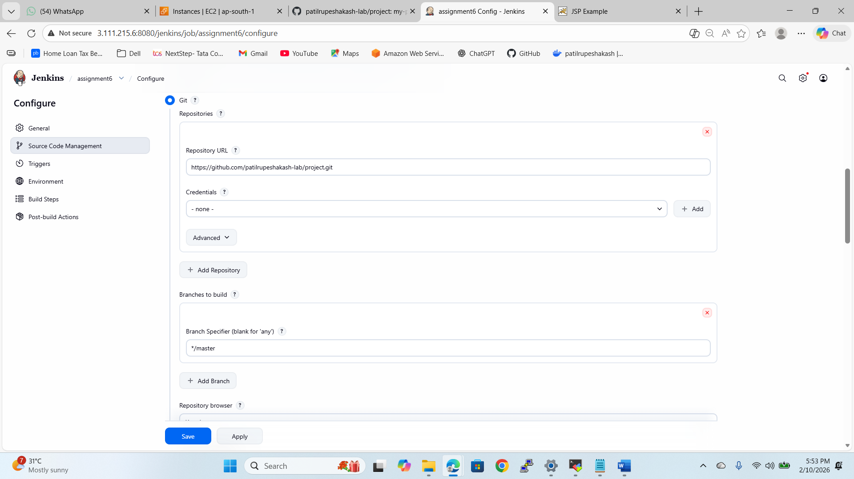
Invoke top-level Maven targets for Maven
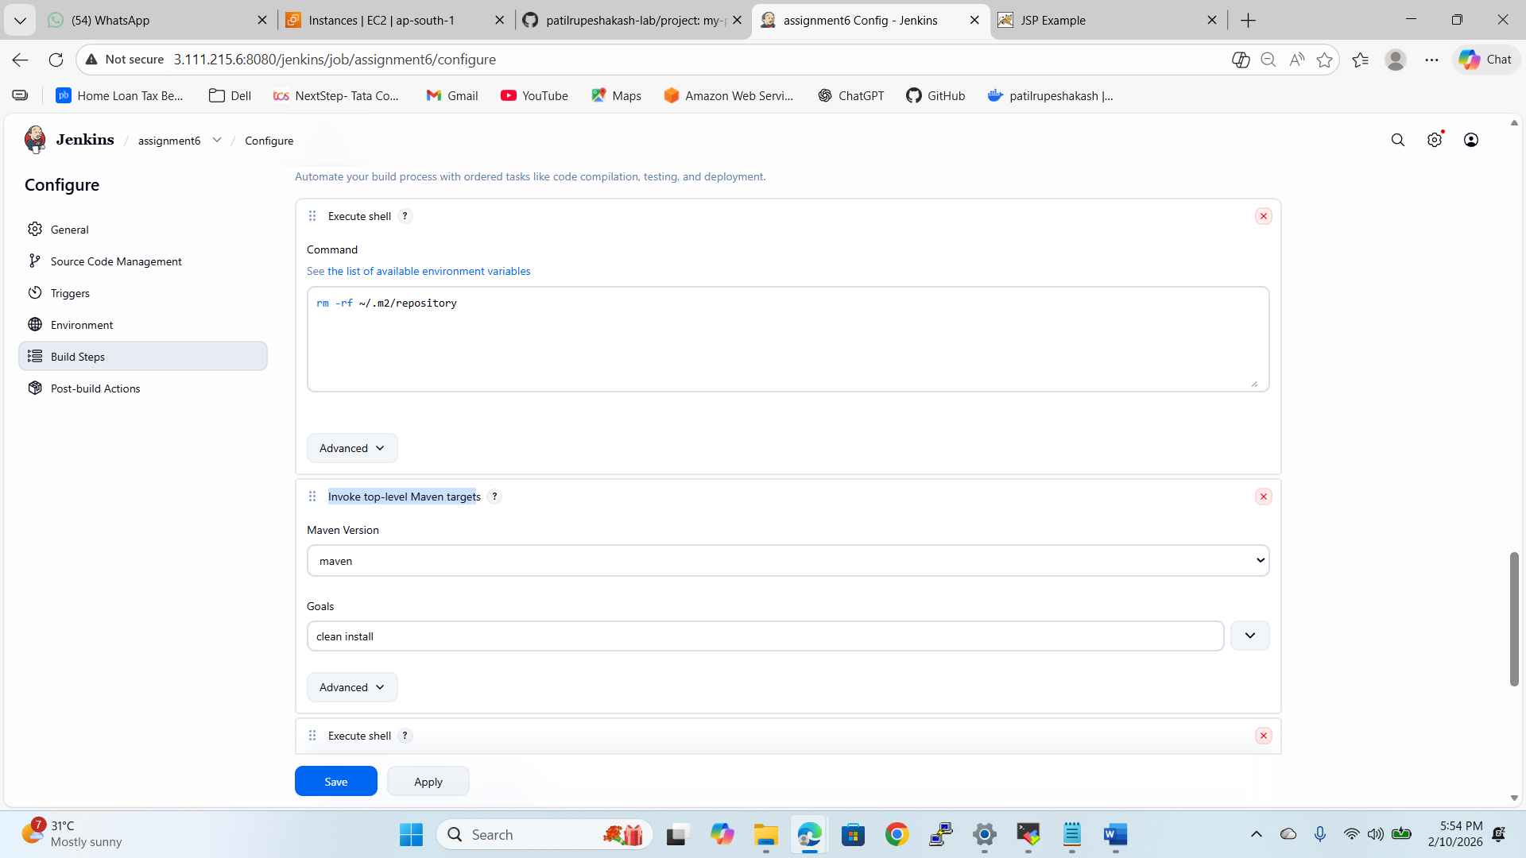

Copied the WAR file from target floder to the webapps folder
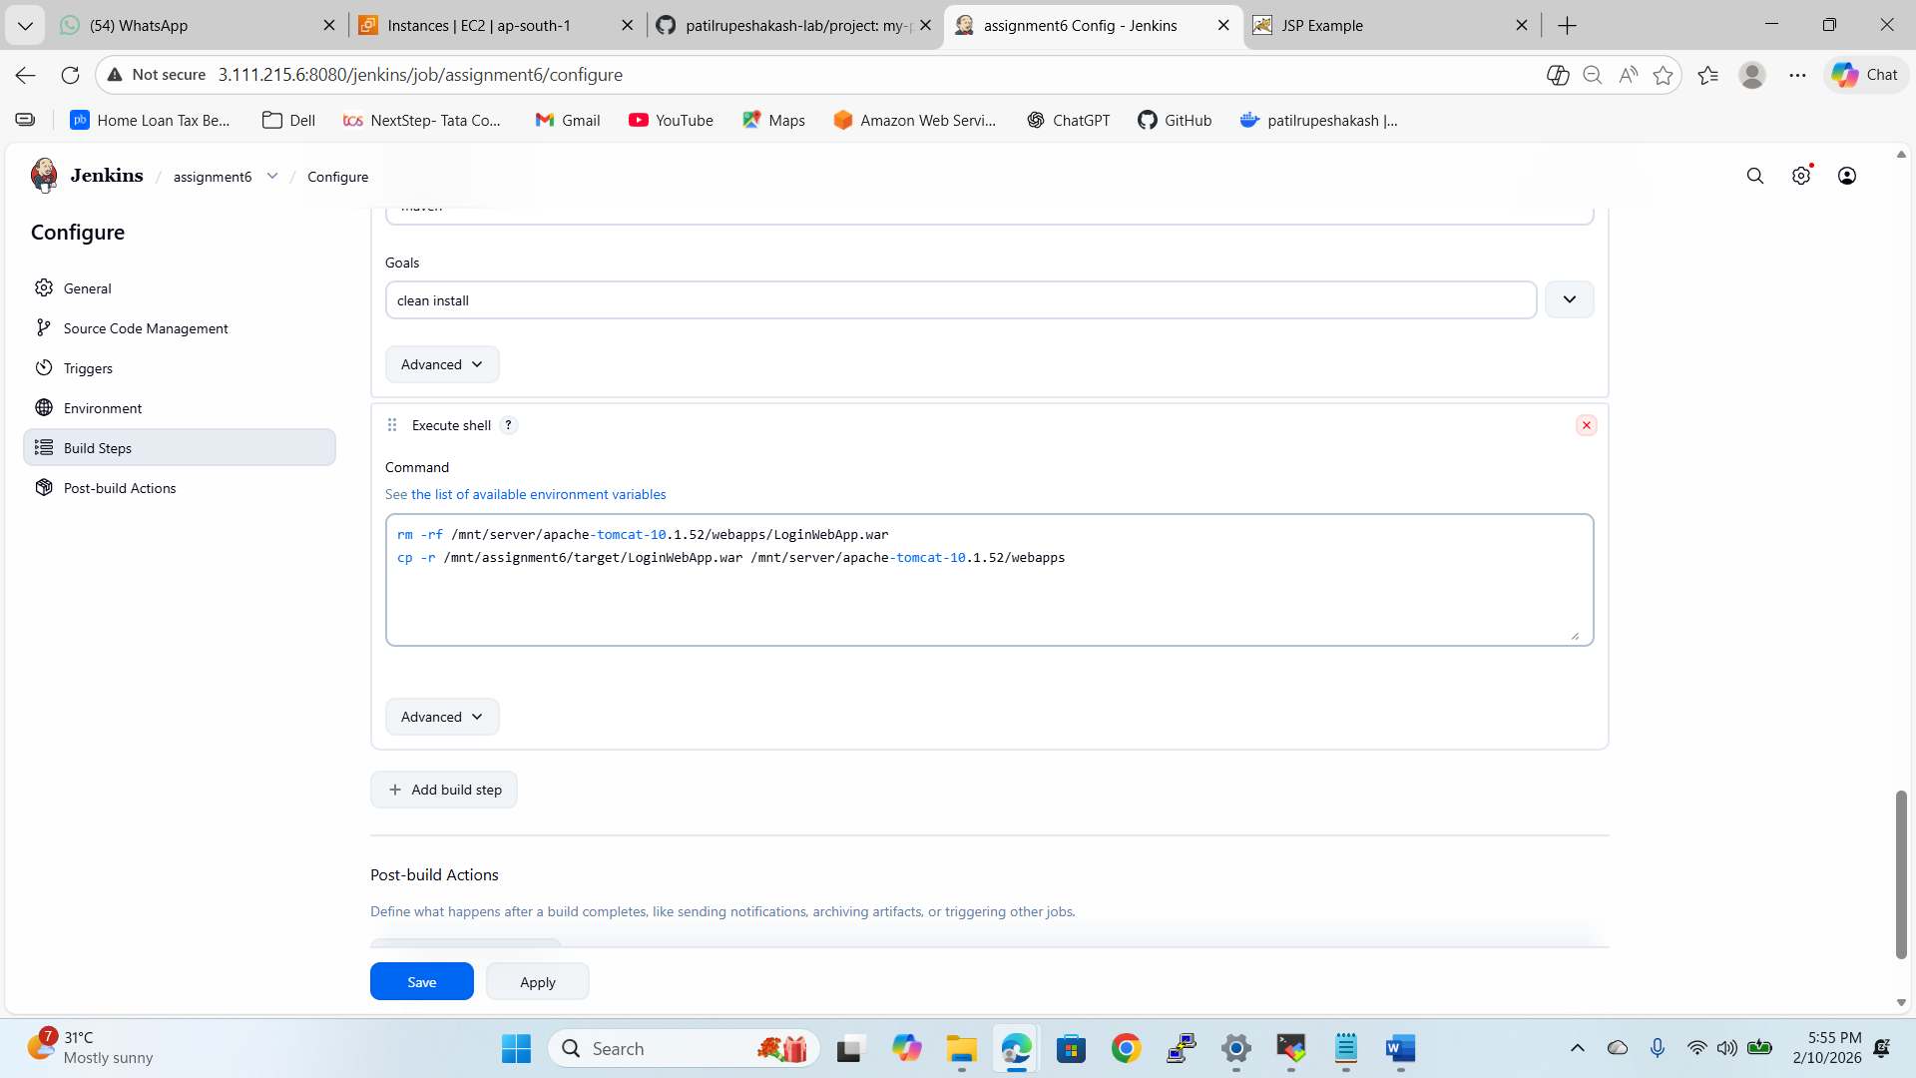
Website is running
